Fontys University Of Applied Sciences

MusicMaven

Software Solution

Project plan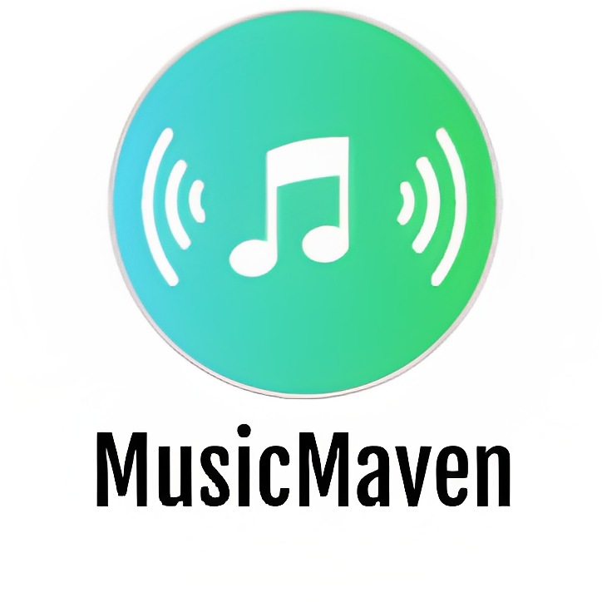

*Software Engineering*

**Author:**

Martin Hristev

*Version: 0.2*

Eindhoven

**2 0 2 3**

Table of Contents

**1. Client 3**

**2. Team 3**

**3. Current situation 3**

**4. Problem description 3**

**5. Project goal 4**

**6. Deliverables 4**

6.1 Web Application 4

6.2 Desktop Application 4

**7. Non-Deliverables 4**

**8. Constraints 5**

**9, Phasing 5**

# 

# 

# 1. Client

The client for this project is a company called Spotify, which is a leading music streaming platform. Spotify is looking to expand its services by creating a web application for music reviews. Currently, the company has other products and platforms related to music streaming. As the project progresses, the team will work closely with the client to ensure that the product meets their requirements and expectations.

# 2. Team

The main developer for this project is Martin Hristev. He can be reached at [m.hristev@student.fontys.nl](mailto:m.hristev@student.fontys.nl). The company that he represents is MusicMaven.

The project will also have the support of three tutors who will provide guidance and feedback throughout the development process.

The tutors for this project are:

* Marcel Boelaars (WAD) - [m.boelaars@fontys.nl](mailto:m.boelaars@fontys.nl)
* Jesús Ravelo Sánchez (OOD) **-** [j.ravelosanchez@fontys.nl](mailto:j.ravelosanchez@fontys.nl)
* Stan van Hartingsveldt (WKS) - [s.vanhartingsveldt@fontys.nl](mailto:s.vanhartingsveldt@fontys.nl)

# 3. Current situation

Spotify is a well-known music streaming platform with millions of users all around the world. While Spotify provides an excellent platform for music lovers to listen to their favorite songs and playlists, it doesn't offer a way for users to connect and share their opinions and thoughts on new album releases, songs, and artists. This is a significant gap in the market, as there are many music enthusiasts who would love to connect with other like-minded individuals and discuss their favorite music.

# 4. Problem description

The current situation in the music industry is that while streaming platforms like Spotify provide users with access to millions of songs, they do not have a built-in mechanism for music lovers to share their thoughts and opinions.

The problem that the client faces is the lack of a community platform for its users.

Music lovers often rely on social media platforms to connect with others and share their thoughts on the latest music. However, this is not an ideal solution, as social media platforms are not designed specifically for music discussions, and music-related content can easily get lost in the noise.

# 5. Project goal

The goal of the project is to create a platform that brings music enthusiasts together to share their opinions and thoughts on the latest album releases, songs, and artists. The platform should provide a space for users to engage with the community, discover new music, and explore a variety of music-related reviews.

# 6. Deliverables

The deliverables of this project include a web application and a desktop application.

## 6.1 Web Application

The web application will aim to provide a personalized review system for users to rate and share their opinions on the latest music releases. This review system will be tailored to each user, allowing them to rate albums, songs, and artists on a scale of 1 to 10 stars and leave a description to explain their rating. Users will also be able to follow other music lovers on the platform, stay updated with their latest reviews and recommendations, and engage with the community by liking reviews. In addition, the web application will include a music discovery feature that allows users to explore popular reviews and recommendations from the community, even without logging in.

The web application will also integrate with the Spotify API to generate a random playlist based on user input. Users will be able to input their favorite artist, genre, or song, and the platform will generate a playlist based on their preferences.

## 6.2 Desktop Application

The desktop application will be used for administration purposes, allowing the administrator to manage user accounts, add new albums, artists, and songs to the platform, and perform other administrative tasks.

# 7. Non-Deliverables

1. The web application will not provide a feature for music streaming.

Users will only be able to share their opinions and recommendations about music, but they will not be able to listen to music directly on the platform.

1. The desktop application will not have a feature for data analysis or reporting.

The application will only be used for administration purposes, such as managing user accounts, adding new albums, artists, and songs to the platform.

1. The project will not involve developing a mobile application.

The web application will be accessible via mobile devices, but it will not have a dedicated mobile application.

1. The project will not involve any third-party integrations besides the Spotify API.

Other music streaming platforms or social media platforms will not be integrated into the platform.

# 8. Constraints

1. Time Constraint

The project needs to be completed within a certain time frame. The project timeline is set to 18 weeks.

1. Technical Constraint

The web application needs to be developed using specific programming languages and frameworks. The web application will be developed using the .NET framework and the front-end will be built using HTML, CSS, and JavaScript.

1. Milestones Constraint

The project has a set of milestons for completion. Project deliverables need to be completed and tested before each milestone.

# 9, Phasing

The project will be divided into several phases with specific deliverables and milestones. The timeline is set for 18 weeks.

**Phase 1**: Planning and Design

*Weeks 1-3*

During this phase, the team will conduct research on the market trends and analyze the user requirements to design a plan for the project. This will include creating wireframes, flowcharts, UML and user interface designs for the web and the desktop application.

*Milestone 1*: Finalize the project plan, ideation document, URS, and UML and present it to the tutor for approval.

**Phase 2**: Front-end Development

*Weeks 4-7*

1. During this phase, the team will focus on developing the basics of the front-end of the web application and finish the GUI for the Desktop application.
2. The back-end of the Desktop application will be finished.
3. Integration of MSSQL

*Milestone 2*: Complete the front-end development and the back-end of the Desktop application and present it to the tutor for review and feedback.

**Phase 3**: Back-end Development

*Weeks 8-11*

In this phase, the team will work on the back-end development of the web application, implementing user authentication.

Milestone 3: Complete the back-end development and present it to the client for review and feedback.

**Phase 4**: Testing and Deployment

*Weeks 12-15*

1. The team will integrate the platform with Spotify API to generate a random playlist based on user input and build additional UI for the additional features.
2. During this phase, the team will conduct thorough testing of the web application to ensure its functionality, performance, and security.

Milestone 4: Complete testing and deploy the web application to the production environment.

**Phase 5**: Maintenance and Support

*Weeks 16-18*

After deployment, the team will provide maintenance and support services like fixing bugs and adding new features.

Milestone 5: Finalize the maintenance and support services and present the final product to the client for approval.

After the completion of each phase, there will be a meeting with the tutors, where the developer will present the completed sub-deliverables for review and feedback before proceeding to the next phase.